

Handheld Welding Machine
Instruction Manual

Headquarters address：Room 503, Building 1, Nantai Yunchuanggu Park,
Southeast of the intersection of Guangming Avenue
and Dongchang Road, Tangwei Community, Phoenix
Street, Guangming District, Shenzhen

Production Base：Dongguan and Nantong (Two big Production Base)

Website: www.dplaser.com

Statement

1. Shenzhen Dapeng Laser Technology Co., Ltd. may update the instruction manual at any time due to software or hardware upgrades. These updates will be included in the new version of the instruction manual. The final version of the instruction manual shall prevail. Any changes will be made without prior notice. Use You must read the instructions carefully before welding the machine!
2. If you purchase a Dapeng laser handheld welding machine, you will enjoy lifetime software upgrade service. Within the specified warranty scope, Shenzhen Dapeng Laser will fulfill its promised warranty service. It is strictly prohibited to disassemble this product without permission or to repair it by personnel outside the company. If the product is damaged due to the above factors, our company will not provide any free warranty service. Our company is not responsible for any losses that may be caused during the use of this product. The contents contained in the instruction manual may not be modified or copied by any means by any organization or individual. The final interpretation right of this product description belongs to Shenzhen Dapeng Laser Technology Co., Ltd.

Contents

- Start-up sequence and instructions for using the welding head

- Precautions for safe operation and use

- System introduction and use

- Technical parameters of swing welding joint

- Wire feeder and accessories

6. Pre-sales, sales and after-sales services
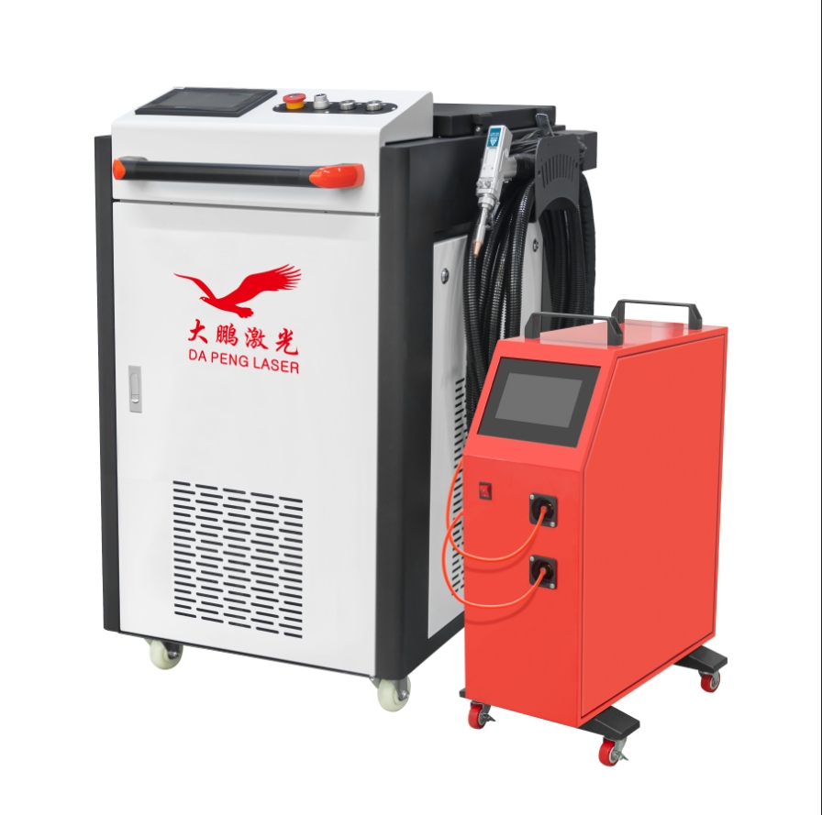
Laser Safety, Operating Safety Notices
Please pay attention to the following matters when operating and installing:
1) Please use this product correctly according to the instructions for use. Please do not damage the power supply or step on, twist or pull the cable. Damage to the cable may cause electric shock, short circuit, or fire.
2) When there is a burning smell, abnormal sound, abnormal heating, smoke and other abnormal phenomena, please turn off the power to stop operation, otherwise there is a risk of electric shock, fire, etc.
3) Foreign objects, especially metal or conductive objects, should be avoided inside the circuit to prevent short circuit or malfunction. Do not use it in a humid environment. Contact with water in the electrical part may cause electric shock or short circuit. Do not use it when not working. Connect it to power.
4) Please wear protective glasses and safety gloves during laser processing. After powering on and turning on the laser power, it is strictly forbidden to point the muzzle at the human body and eyes. After processing is terminated, the workpiece is still at high temperature, so please wear gloves to touch the workpiece.
5) During welding, the welding parts and the operating platform are prohibited from being connected to the earth. Use them correctly and safely to expose the light. The muzzle of the gun is strictly prohibited to be pointed at the eyes and skin.

Boot Sequence

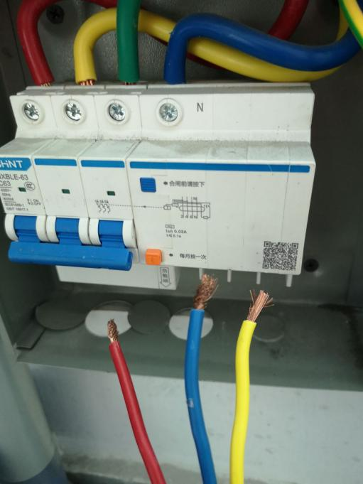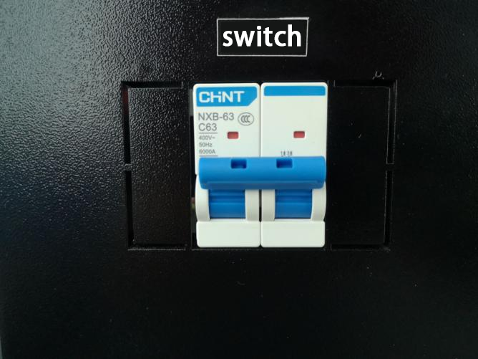
1. The voltage used by this product is AC 380V (depending on the power). Connect the power cord to the 380V power supply as shown in the figure.
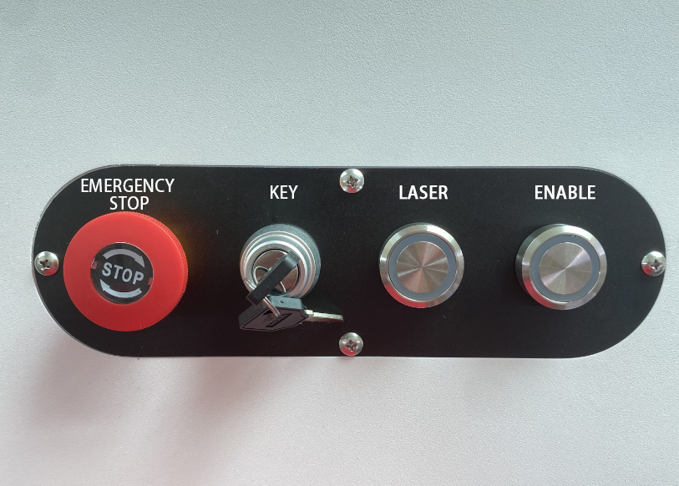
2. Turn on the air switch of the equipment, and then turn on the emergency stop and key switch. After the welding machine is powered on, the cooling fan and water chiller will run automatically (check whether the emergency stop and key switch are turned on before running). If the water chiller is not filled with water, an alarm will occur. Inject distilled water into the chiller to the green normal area. If the alarm still occurs, please re-run the chiller and ensure that the working area on the chiller display is in operation.
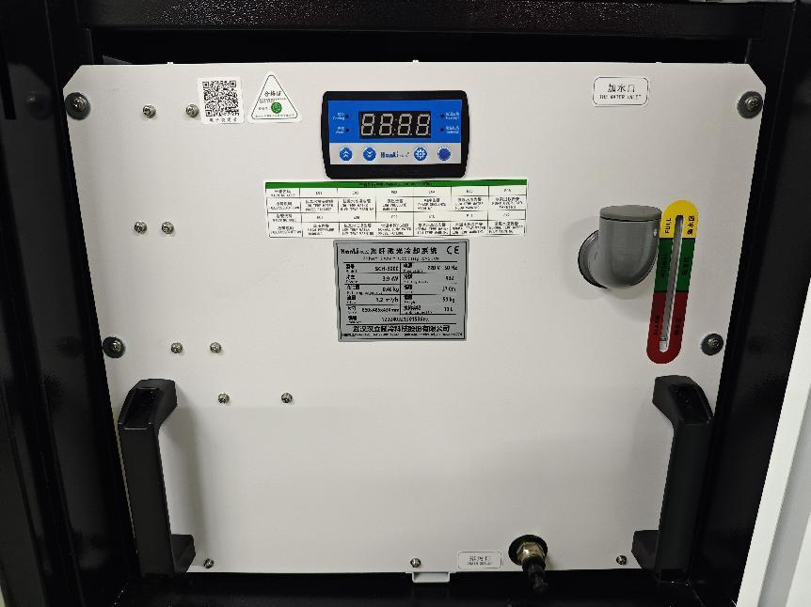

3. When the chiller is running normally, wait for the chiller to control the water temperature at the set temperature before turning on the laser button. Wait for more than 3 seconds, and there will be a "beep" sound inside the equipment. At this time, the enable button can be turned on, otherwise it will be invalid.
Laser indicator light: ALARM green, ACTIVE red, POWER green, it is normal.
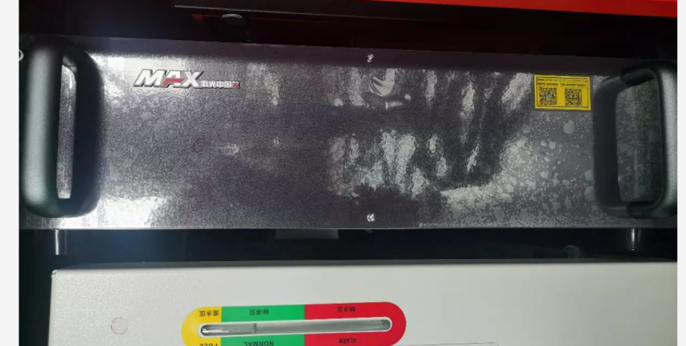
4. Before using the optical fiber handheld welding machine, protective gas (nitrogen or argon) needs to be injected. The rear of the equipment is equipped with a protective gas interface (PM10). The gas size should be adjusted according to the welding product (not less than 0.15MPa).
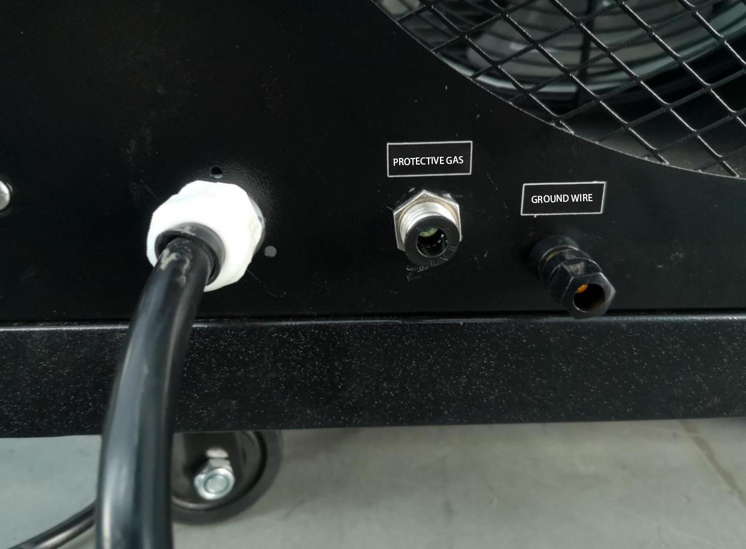

5. After completing the above operations, the handheld gun can be used normally.
How to use: Clip the alligator clip to the object that needs to be welded or the metal operating table that is connected to the object (make sure it is within 3M and not covered by paint). Then gently touch the nozzle of the gun to the welding position, press and hold the trigger button, and stretch it at a constant speed at an angle of about 45°. Release the trigger button to stop emitting light. (There is no need to stretch the wire for welding, the wire will push the gun body to weld by itself)

Precautions for use:
Before using the equipment, check whether the protective gas is turned on.
Protective glasses are required when using the equipment.
It is prohibited to point the gun at the human body.
Please turn off the enable if you want to leave temporarily.
Precautions when holding a gun
1. There are no built-in parts for use. All repairs should be carried out by our company's professionals. Please do not damage the label or remove the cover of the welding gun head, otherwise our company will not guarantee any damage to the product!
2. Please do not look directly at the light outlet of the welding head. You must wear professional laser goggles during operation!
3. Continuous interruption of power supply will cause damage to the welding control system. Please provide continuous and reliable power supply!
4. The external safety lock is 24V high level. Please do not short-circuit the aviation plug GND shell of the system cable, or accidentally collide with each other during installation. Otherwise, the short circuit may burn the power supply or main control board. After the gun head aviation plug is connected, Use insulating tape to wrap and insulate!
5. For control circuits, please note that the 24V input must be supplied to the welding system at the same time, otherwise it may cause signal transmission errors.
6. When installing the QBH, pay attention to the cleanliness of the surrounding environment. The fan should be turned off and there should be no flying dust. The QBH must be wiped clean before inserting into the gun body, otherwise the collimation lens will be burned!
7. The optical lenses in the welding head are all consumables (collimation, focusing, protective lenses). If they are damaged, they will not be covered by the warranty: our company promises that the consumable parts will be repaired during the warranty period if they are sent back to our company for replacement. Product maintenance charges include material costs and no other fees are charged. Non-consumable parts are accessories that are not damaged by humans. During the warranty period, our company bears all maintenance costs.

Water machine maintenance:
The water level in the chiller must be in the green area of the water tank level indicator.
After adding water for the first time or renewing the water, the air in the water pump needs to be drained. Operation method: Slowly loosen the exhaust screw plug under the water inlet. Wait until water flows out before tightening.
It is recommended to change the water once every quarter (3 months).
Antifreeze in winter:
1. When new equipment is transported or not used for a long time, the water in the water tank should be drained through drainage.
2. If the ambient temperature at night is lower than 2℃, it is recommended that the customer does not stop the machine/add car antifreeze. When the daily average temperature is higher than 5℃, replace the water containing antifreeze with pure water.
Dust prevention in summer: Clean the air conditioner filter of the chiller for about a month in summer.

Welding Gun System Parameters
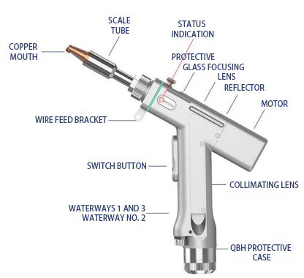

Input voltage(V) | 220V±10% AC 50/60Hz
Installation  Environment | Smooth, vibration-free and shock-free
Working environment temperature (℃) | 10～40
Working environment humidity (%) | ＜70
cooling method | water cooling
Applicable wavelength | 1064nm（±10nm）
Applicable power | ≤3000W
collimation | D16*5/F60
focus | D20*4.5/F150
reflection | 30x14xT2
Protective mirror specifications | D18*T2
Maximum supported air pressure | 15Bar
Focus vertical adjustment range | ±10mm
Scan Width - Welding | 0~8mm
Scan Width-Clean | F150-0~30mm
Scan Width-Clean | F400-0~60mm
Scan Width-Clean | F800-0~120mm
Gun body net weight | 0.75kg

Attention information
1) Ensure reliable grounding before supplying power.
2) The laser output head is connected to the welding head. Please check the laser output head carefully when using it to prevent dust or other contamination. Please use special lens paper when cleaning the laser output head.
3) If the equipment is not used according to the method specified in this manual, it may be in abnormal working condition and cause damage.
4) When replacing protective glasses, please make sure to take protective measures.
5) Please note: When using it for the first time, when the red light cannot come out from the copper mouth, be sure not to let the light come out.

System introduction and use
1.Operation overview and operation guide
The operation panel of the SUP series is mainly composed of a touch screen and a control box. The touch operation interface mainly includes home page, process, settings, monitoring and other parts.
  - Touch screen operation main screen

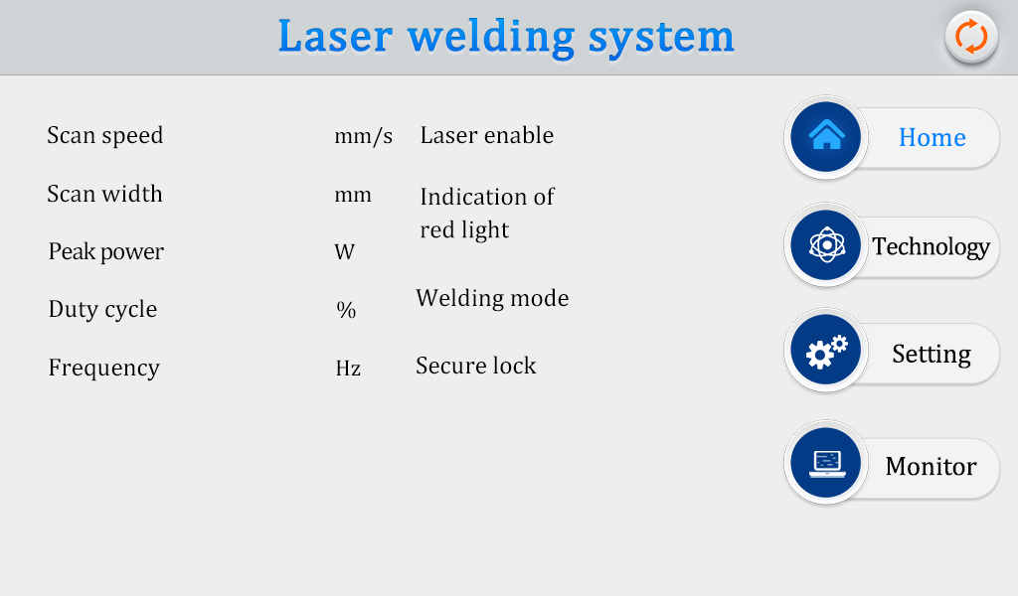
①On this interface, you can see the current process parameters and real-time alarm information.
②When the machine is powered on, the laser enable and indicator red light are ON.
③The safety lock is usually gray. When the welding head contacts the workpiece, it turns green and can be processed.
④Welding mode selection, the default is continuous. When set to spot welding, the light can be emitted intermittently for spot welding operations, which is convenient for controlling the spot welding time due to manual inconvenience. This function needs to be set as needed (V3.3 version is the above function). Click the upper right corner to switch the cleaning mode .

1.2 Process operation main screen

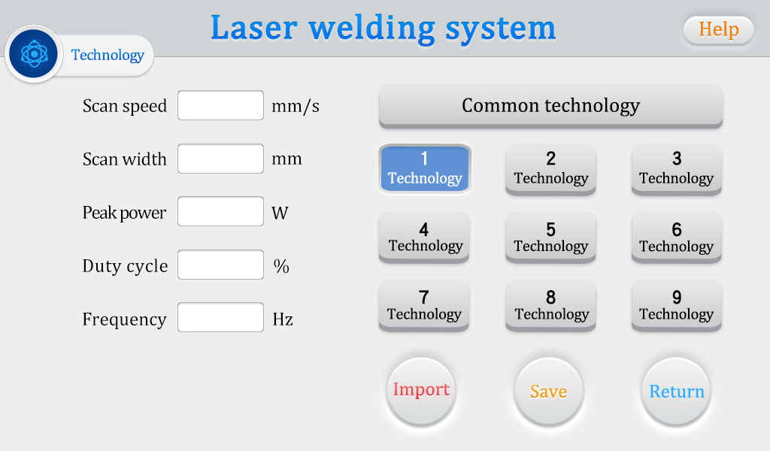
① The process interface contains the process parameters for debugging, which can be modified by clicking on the box. After modification, click OK, then save it in the quick process, and click import when using it (Modify-Save-Import).
②Scanning speed range 2-6000mm/S, scanning width range 0^5mm. The scanning speed is limited by the scanning width. The limiting relationship is: 10≤scanning speed/(scanning width*2)≤1000. If the limit is exceeded, it will automatically become the limit value. When the scanning width is set to 0, it will not scan (i.e. point light source) (the most commonly used scanning speed: 300mm/S, width 2.5mm).
③The peak power must be less than or equal to the laser power on the parameter page (if the laser power is 1000W, then this value shall not be higher than 1000).
④Duty cycle range 0~100 (default 100, usually no need to change).
⑤The recommended pulse frequency range is 5-5000Hz (default 2000, usually no need to change).

Process reference (subject to actual situation, the following is for reference only)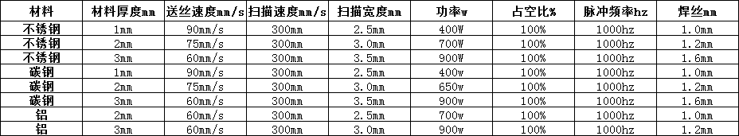

1.3 Set the main screen of operation
Password: 123456
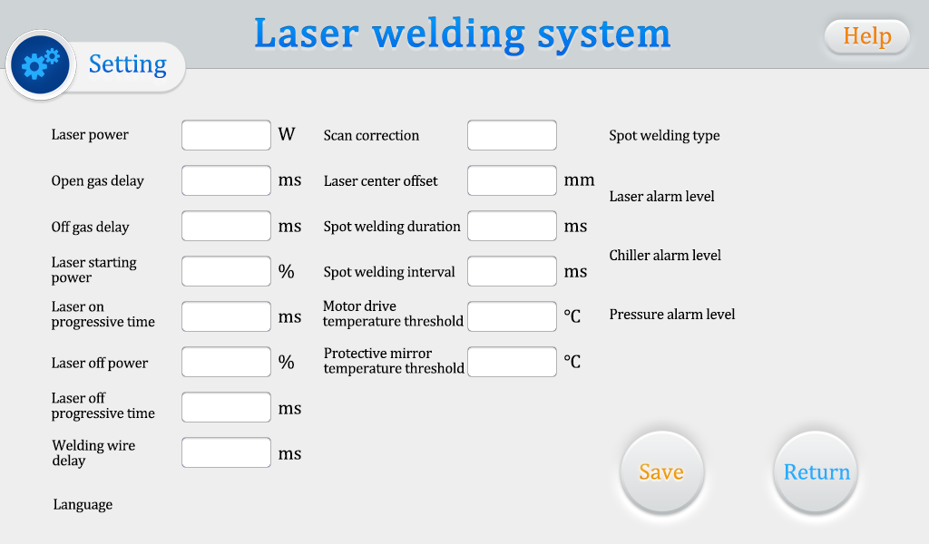

①The laser power is the maximum power of the laser used.
②The default switch gas delay is 200ms, and the range is 200ms-3000ms.
③When the light is turned on, it gradually changes from N1% of the process power to 100%; when it turns off the light, it gradually changes from 100% of the process power to N2; (as shown in the figure below).
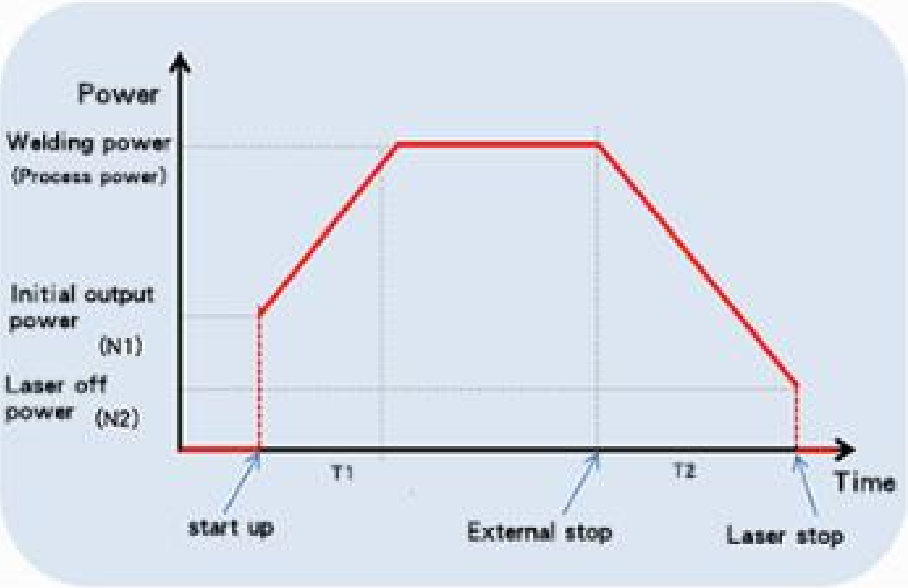
④ Wire feed delay compensation is the wire feed advance time relative to the light signal, and can be used with the retraction function.
⑤The maximum temperature alarm threshold is 70℃. When this value is set to 0, the temperature alarm will not be detected.
⑥Scan correction coefficient range is 0.01~4, coefficient target line width/measurement line width: generally 1.25.
⑦The laser center is offset by -3~3mm. If it decreases, move to the left; if it increases, move to the right.
⑧The alarm level signal is the default, and the shielded alarm can be directly changed to the corresponding level detection.
⑨The spot welding duration is the light emitting time after the trigger is pulled, that is, even if the button is released, the light will still be emitted according to the emitting time (V3.3 version has the above function)
⑩The spot welding interval is the light-off time between two spot welds after the trigger button is pulled (V3.3 version and above function)
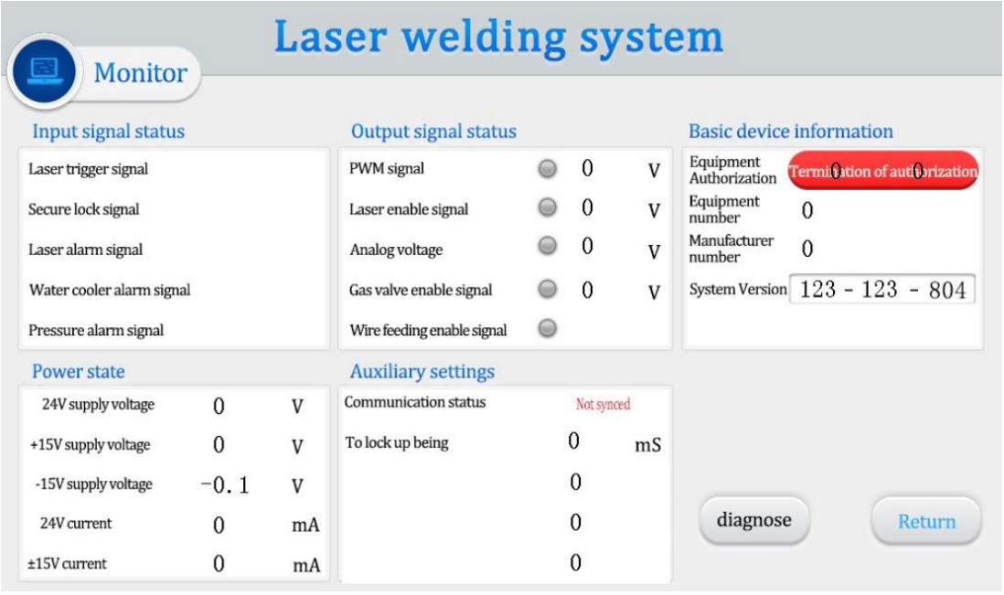
This interface displays the status of each detection signal and device information.
Click Device Authorization to enter the authorization duration interface. After entering the password, you can authorize the system for the duration of use.

Welding Gun Cutting Mode Parameters
Cutting must use a cutting nozzle, and cutting is an incidental function. It is not recommended to cut for a long time or to use it as a special cutting machine.
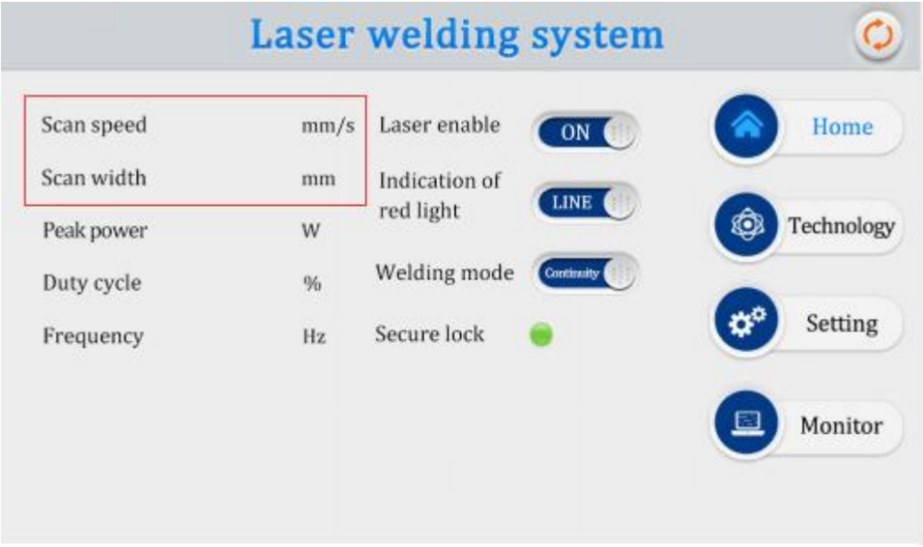
【Scan width】is set to【0】, which means that the【copper nozzle】for cutting can be replaced and the cutting operation can be carried out. During laser cutting operations, it is necessary to ensure that the【Safety Ground Lock】is turned on. Note: The cutting nozzle must be used for cutting, the red light must be in the center of the cutting nozzle, and cutting is an incidental function. It is not recommended for long-term cutting or use as a special cutting machine.

Welding gun cleaning mode parameters
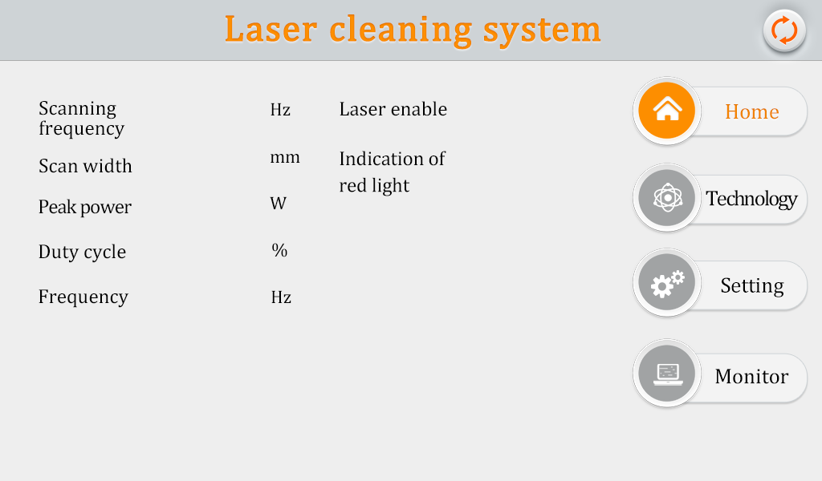
① You can see the current process parameters (the process cannot be modified on this page) and real-time alarm information on the interface.
② In the power-on state, the enable default is ON, and the red light indicator defaults to LINE. When the enable is turned off, the enable signal will not be sent to the laser and can be used to test the air outlet function. Turn off the red light indication and the motor stops swinging. At this time, the red light is a point, which is used to adjust the center position.
③Click the upper right corner to switch cleaning mode.
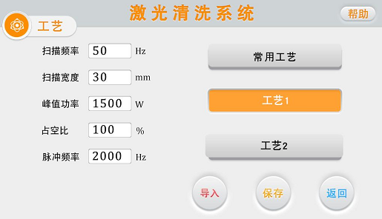
① The process interface contains debugged process parameters. Click the box (red) to modify it. After modification, click OK, then save it in the quick process, and click import when using it (Modify-Save-Import).
②Scanning frequency range 10-100HZ, scanning width range 0^30mm. (When the focusing mirror is F800, the maximum width is 130mm. When the focusing mirror is F150, the maximum width is 30mm).
③The peak power must be less than or equal to the laser power on the parameter page.
(If the laser power is 1000W, this value shall not be higher than 1000).
④Duty cycle range 0~100 (default 100, usually no need to change).
⑤The recommended pulse frequency range is 5-5000Hz (default 2000, usually no need to change).
⑥Click the "Help" button on the upper right to get more explanations of relevant parameters.
⑦After modifying the parameters, you can check whether the import is successful on the home page.
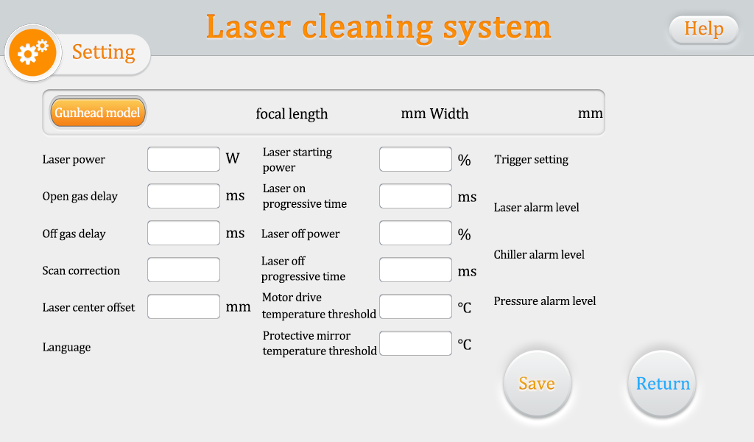
Password 123456
①The laser power is the power of the laser used, please fill it in correctly.
②The default switch gas delay is 200ms, and the range is 200ms-3000ms.
③ When turning on the light, it gradually increases from N1% of the process power to 100%; when it turns off the light, it gradually increases from 100% of the process power to N2; (as shown in the figure below).
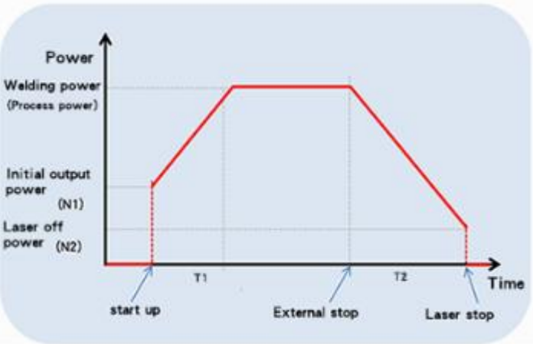
The higher the process power, the lower the light power is recommended. The light power should usually not exceed 50%. Excessive light power will greatly reduce the service life of the lens.
④The maximum temperature alarm threshold is 65℃. When this value is set to 0, the temperature alarm will not be detected.
⑤Scan correction coefficient range is 0.01~4, coefficient target line width/measurement line width: the default is 1.0.
⑥Laser center offset: Cleaning mode only displays the current offset. If you need to adjust the center, please switch back to welding mode and replace the F150 focusing lens for adjustment to ensure accuracy.
⑦The air pressure/water cooler/laser alarm level signal defaults to low level. When using this alarm signal, if an external air pressure alarm is installed, it will be changed to high level. Otherwise, abnormal alarms and other alarm signals will occur. Same reason.
⑧Click the "Language" button to switch to other languages in the language selection bar. Currently, the standard version supports nineteen languages. If you need other language versions, please contact our company.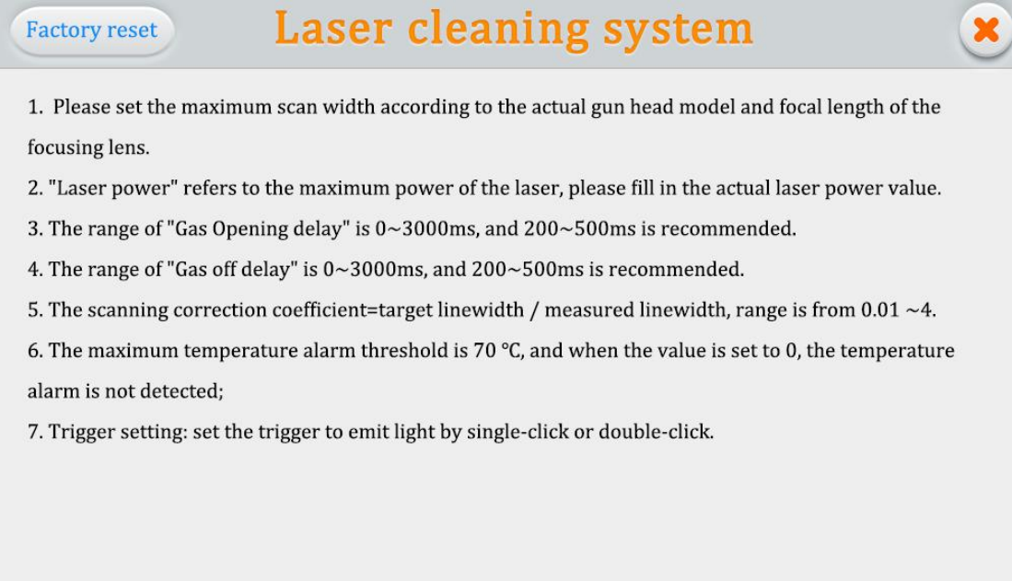
⑨Click "Help" in the upper right corner to enter the setting page help page. Press and hold "Restore Factory Settings" to restore the setting parameters to the factory state. Long press "Save as factory settings" to modify the factory parameters.
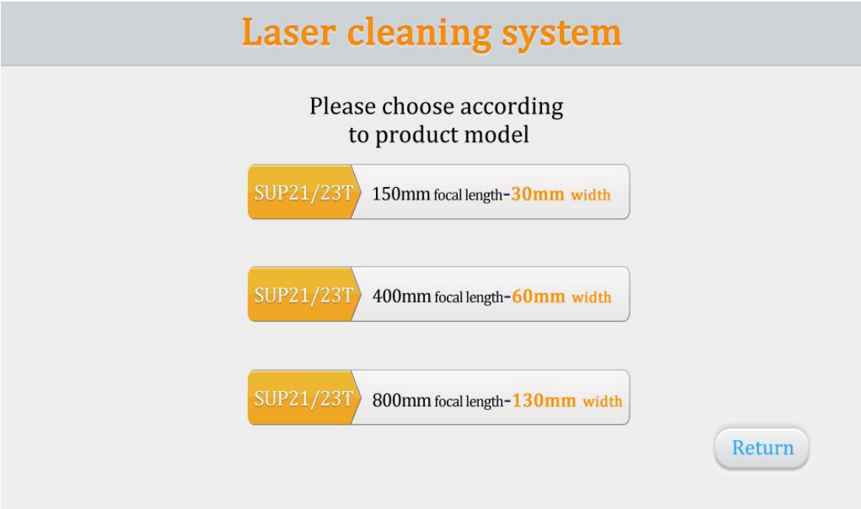
⑩Click "Gun Body Model" and select the maximum scanning width for the focusing mirror.
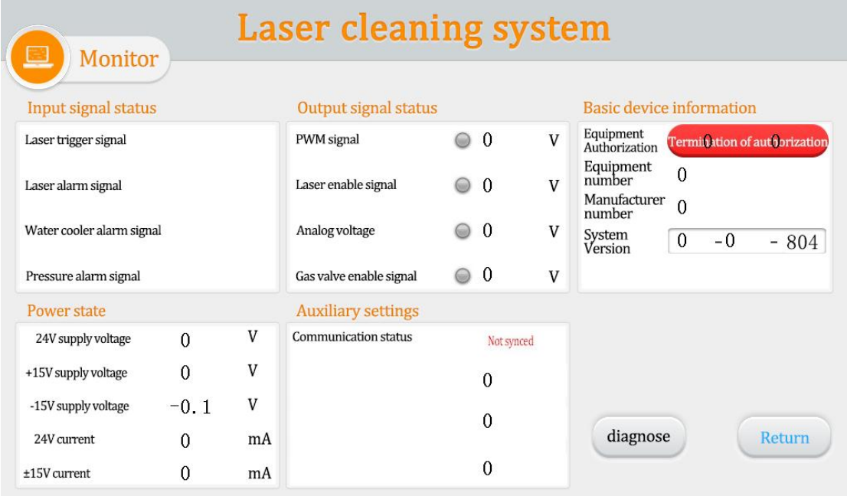
This page displays the status of each signal and device information
Laser trigger signal: When the trigger is pulled, this status changes from gray to green to take effect.

Laser/water cooler/air pressure alarm signal: monitor its set high and low levels
The output signal is displayed in the middle of the page. When the signal is output, it changes from gray to green.
Device authorization: The device can be authorized for use time. When the device is used for more than its set time, the authorization will be terminated.
System version: three groups of numbers, the first group is the hardware version, the second group is the program version of the microcontroller, and the third group is the touch screen version

Welding Gun Care and Maintenance
- How to maintain and replace protective lenses:
① Due to the characteristics of laser welding processing technology, the lens needs to be maintained regularly. If the welding effect is found to be poor, check if the protective lens is dirty and replace the protective lens in time.
② Before operation, wash your hands with detergent and dry them, then wipe your hands again with cotton soaked in alcohol and dry them.
③ Remove the screws of the protective mirror compartment cover in a relatively dust-free place, pull out the protective mirror bracket, protect it, and check the protective lens (if there are obvious burning spots on the surface of the protective lens, it should be replaced directly.)
④ Then check the white power sealing ring under the protective lens. (If the accumulating seal ring is scratched or deformed in any way, it cannot be used and must be replaced immediately.
⑤ Wipe the mouth of the compartment and the inside of the compartment cover with a cotton ball dipped in alcohol, quickly insert the protective mirror bracket into the protective mirror compartment, and tighten the screws.
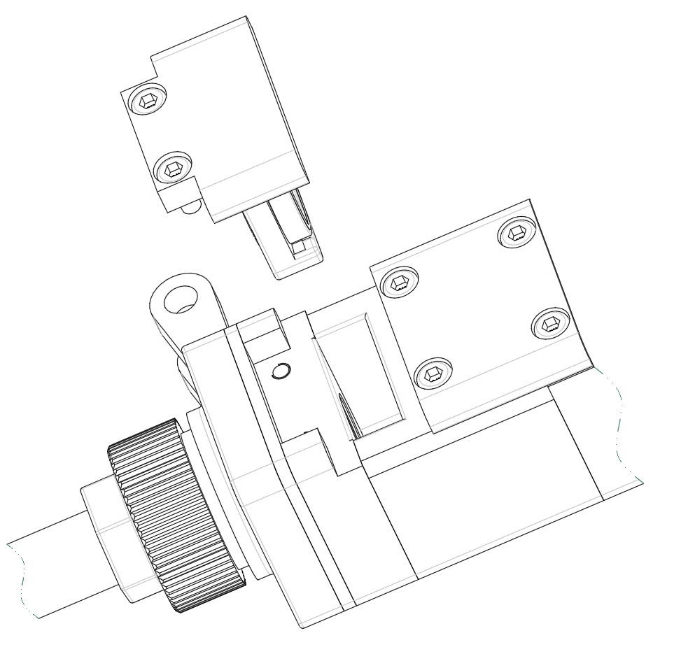

- Laser center adjustment method (tilt viewing angle)
When the red light cannot completely come out of the copper nozzle, manual adjustment is required to prevent burning the copper nozzle.
Please note: When using it for the first time, when the red light cannot come out from the copper mouth, be sure not to let the light come out.
①As shown in the picture below, the red light cannot be seen completely coming out of the copper mouth at this time
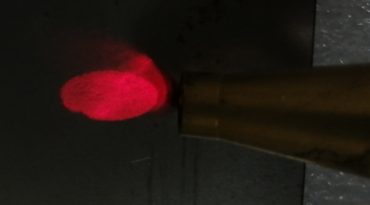
②We need to remove the back cover, you can see four adjustment screws, adjust the center according to the video
③Finally, achieve this effect
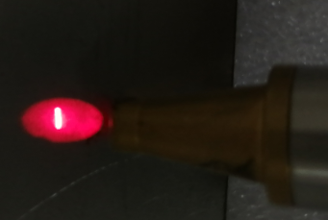
④Slight left and right deviations can be set by setting the panel laser center offset

Common Exception Handling
- Prompt laser/water cooler/air pressure alarm
① If the above alarm occurs without using the alarm signal, please change the alarm level.
② If the above alarm occurs when an alarm signal is used, check whether the alarm of the corresponding device or the high and low levels of the alarm signal are set incorrectly.
2. The screen does not light up/no response when clicking
①The screen does not light up. If the controller is powered on (the fan is running), check whether the four-core wire between the controller and the screen is connected correctly, and whether the 24V voltage between pins 1 and 4 is normal.
② If the click fails during normal use, check whether the temperature of the whole machine is too high.
③ If the click cannot input, check whether the four-core cable between the controller and the screen is connected correctly, and whether pins 2 and 3 are normal.
For details, see 2.1.2 Controller LCD Screen Side
④ If there is no response when clicking on the newly installed device, it may be that the system version does not match. Just re-flash the program. Please contact our company for SD card.
3.No light
① The monitoring interface can eliminate other alarms. When the welding head contacts the workpiece to be processed, the safety ground lock is displayed in green, and processing can be performed at this time. If it is gray, check whether the connection of the safety ground lock is normal.
That is, check whether all preparation signals are normal
Usually, if the air does not come out and the wire does not come out, it is a fault with the laser or there is a problem with the wiring. If there is no air or wire feeding, it may be a signal preparation problem. For details, see: 2.1.3 Controller Signal Interface 1
4.Light output suddenly stops during processing
The monitoring interface checks whether the safety lock and other alarms are normal, and also checks whether the temperature exceeds the temperature alarm threshold.
5.Red light bias
Cause Analysis:
1. External interference sources cause the swing motor to work normally and slowly shift the red light. Try to avoid sharing a power supply box with equipment such as argon arc welders that have a great impact on the power grid. The power supply of the welding head must be effectively grounded. , and isolation transformers, magnetic rings, etc. can be used to eliminate some of the effects
2. Red light shift caused by new QBH replacement, lenses or other replacement parts. When replacing some specific parts, the red light may be inconsistent with the previous one. Make it normal through software settings or mechanical adjustments.
3. The signal wire is broken (only SUP15S welding head), check the five-core wire. This situation is common when the light deviation suddenly cannot be adjusted during normal processing and the motor makes abnormal noise.
Solution：
- Software settings (processing of reason 1/2)
Fine-tune the laser center offset by setting the interface. The order is{1. Setting}-{Change the laser center offset value，egative values go to the right, positive values go to the left. The maximum adjustable value in the latest version is +3/-3}-{3. Go back to the home page, turn off the red light indicator, and then turn on the red light indicator to refresh}。This solution can be fine-tuned left and right，If it still cannot be adjusted using this method, use mechanical adjustment.
- Mechanical adjustment (processing of reason 1/2) (please distinguish between 15S and 20S below)
Before making mechanical adjustments,please be sure to set the center offset to 0. Please refer to the three-step software setting method.
- Disconnection (processing of reason 3)
Check whether there is an open circuit in the aviation plug part of the five-core wire. You need to disassemble the aviation plug.

Laser welding machine three-phase power supply wiring reference
NOTE: Two or three phase power depends on the power required for the laser and chiller, not the amount of wiring harness
Warning: Please be sure not to move/install the machine without permission. Before preparation, please contact our after-sales company to provide the power supply definition of the whole machine, and the whole machine must be grounded! !

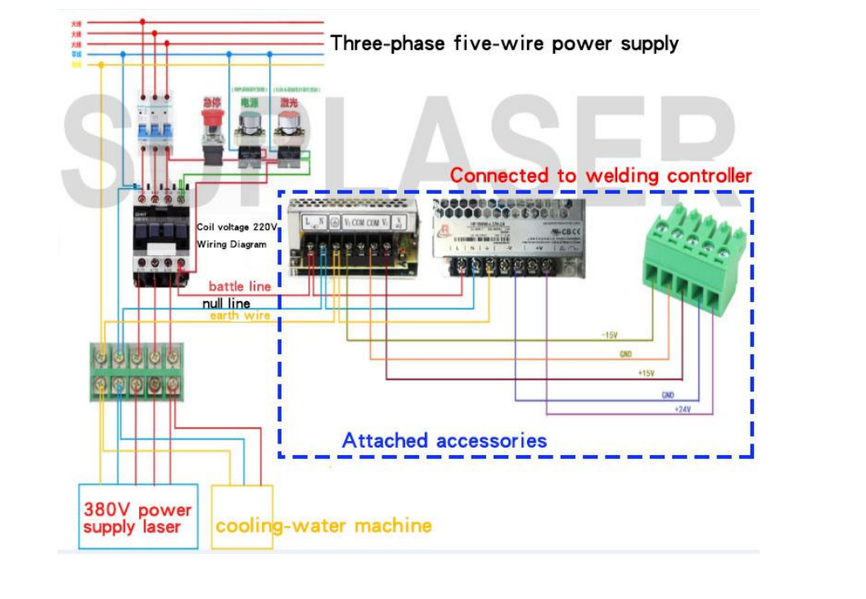

Wire Feeder Structure and Accessories
1．1.1 Operating environment and parameters
Supply voltage (V) | 220±10% V AV 50/60Hz
Placement environment | Smooth, no vibration and impact
Working environment temperature (℃) | 10～40
Working environment humidity (%) | <70
Maximum supported welding wire weight | 25KG
Maximum supported wire feed diameter | 2.0mm

1.2 Attention information
1) Ensure reliable grounding before supplying power.
2) The wire feed wheel matches the wire warp and corresponds to the wire feed tube
3) Do not twist the wire feeding tube
2.Installation
1. General definition of circuit wiring
1.1 The whole machine provides a three-core aviation plug, which is connected to the three-core aviation plug at the rear of the wire feeder to provide 220V power supply.
1.2 The whole machine provides a two-core aviation plug, which is connected to the wire feeding port of the control system and provides a wire feeding signal (passive contact, short circuit means wire feeding)
2. Installation of welding wire spool
2.1 The welding wire is an ordinary welding wire, the common ones are 5KG-30KG, which can be installed, but do not use flux-cored welding wire.
2.2 Use the inner hexagon to adjust the strength of the roller so that it is not too tight or too loose and there is no jamming when feeding wire (usually no adjustment is necessary)
2.3 After adjustment, cover the cap
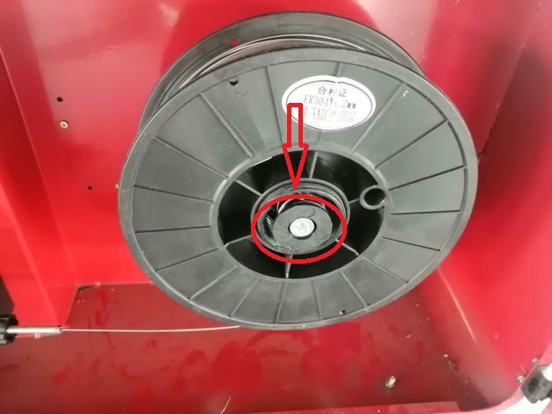
Installation of wire feed roller
- There are two wire feed rollers. The two sides are of different models and correspond to different core diameters.Please be sure to install them accordingly. If you install 1.2 welding wire, the side of the wire feed roller marked 1.2 will be on the outside.
- During installation, the welding wire must be stuck in the slot and then clamped
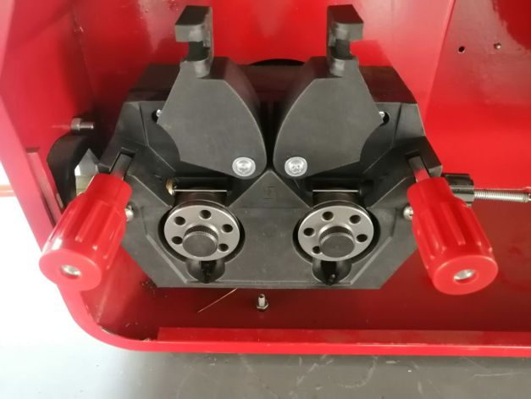
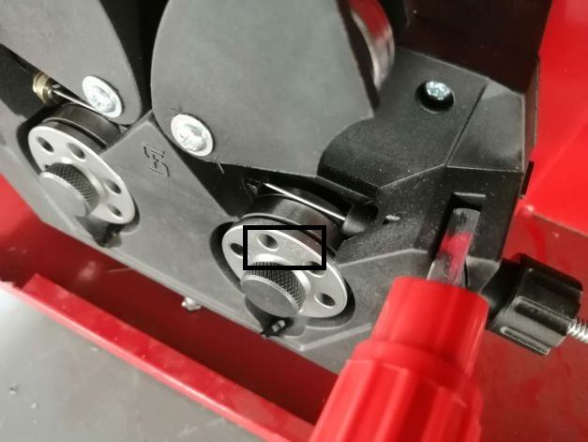

3.Installation of wire feed tube
3.1 After putting the wire into the wire feed tube, insert it into the appropriate position. If it is too short, it may cause the wire to get stuck. Then tighten the screw.
3.2 When installing the wire feed tube, first remove the copper nozzle at the end and match the corresponding copper nozzle.
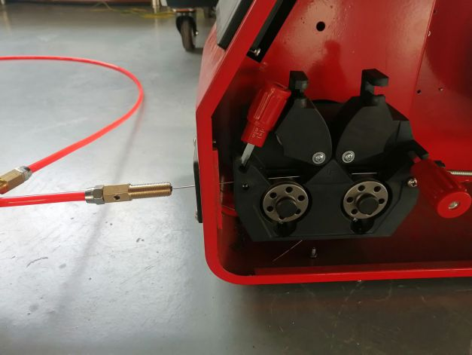

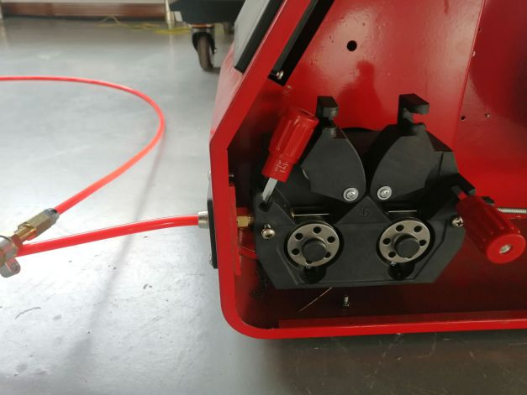

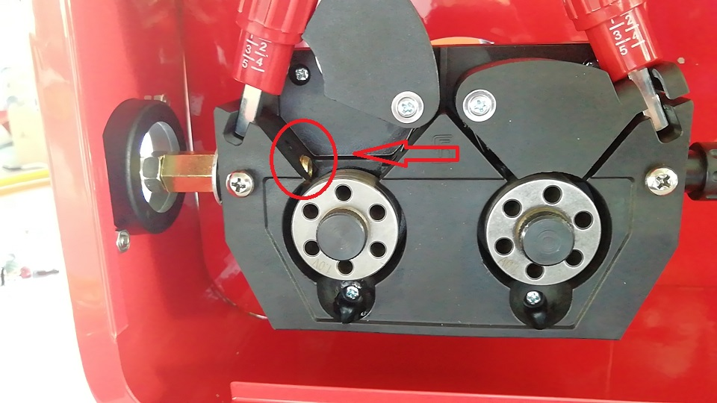

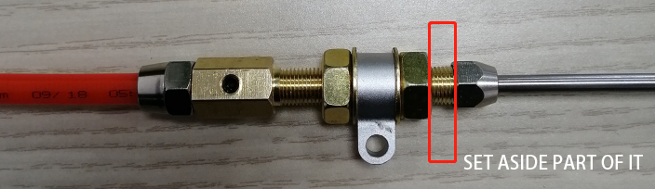
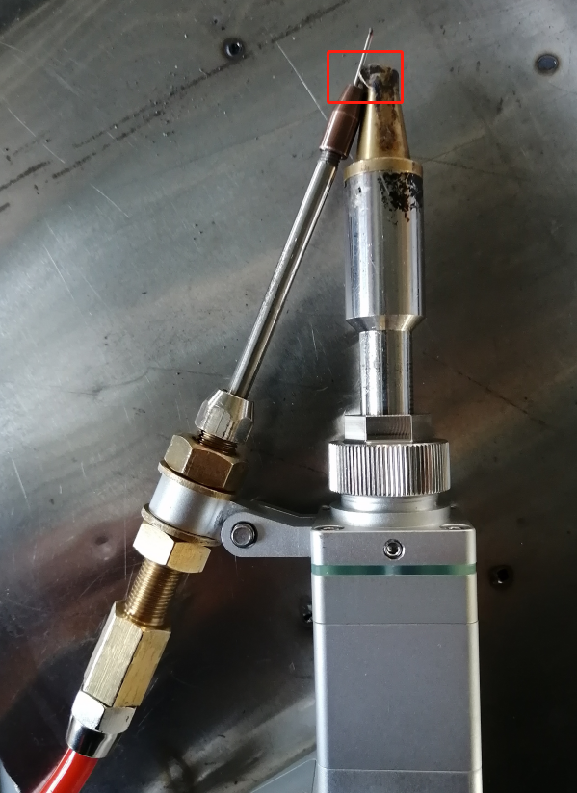
Operation panel
1.The numerical value on the home page displays the wire feed speed, which can be adjusted by using the up and down keys. Please keep it running when using it.
2.Manual wire feeding: After pressing and holding, the wire feeder starts to feed wire. The manual wire feeding speed depends on the background settings.
3.Manual retraction: After pressing and holding, the wire feeder starts to retract. The manual retraction speed depends on the background settings.
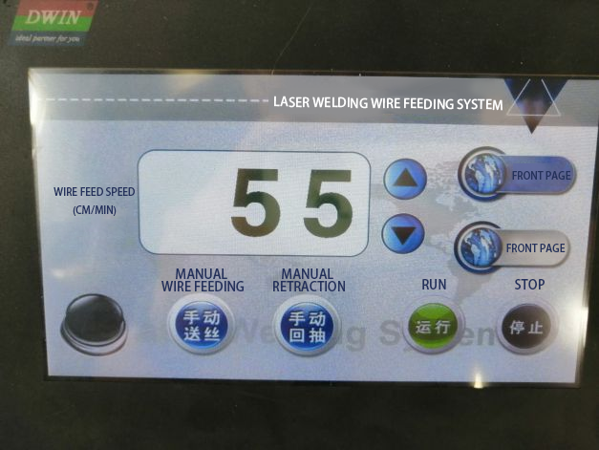
4. After completing all settings on the settings page, click Save
5. The wire feed speed on the setting page is the default wire feed speed, that is, after changing it here, it will remain unchanged when turning on and off the machine.
6. Startup delay: not set by default
7; Withdrawal length and patching length: set according to actual usage
When the wire feeding stops, the system will first retract a certain distance and then feed the wire a certain distance. This function is mainly used for broken wires.
When the wire is still outside at the beginning of each welding, please set the retraction length to be greater than the length of the patch wire.
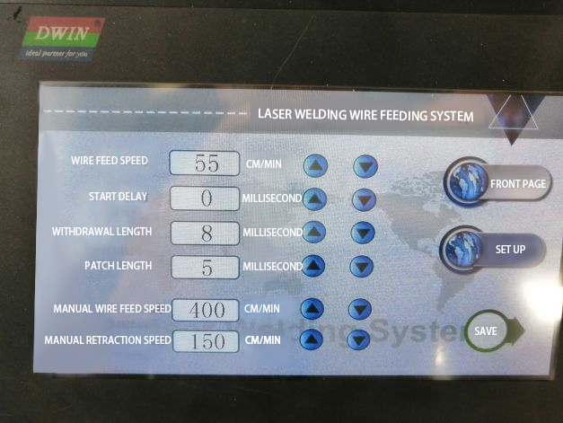

Pre-sales, sales and after-sales services
1. Pre-sales service:
Before signing a contract, the company can provide customers with product samples and technical and price consultation for free.
2. In-sale service:
If you encounter any technical problems during the installation process of the product, you can contact our sales staff and after-sales technicians at any time through whatsapp group or WeChat group for help.
3.After-sales service:
Within the warranty scope of the contract period, the response time of customer service is within 24 hours, and efficient technical service support is provided free of charge to customers during the warranty period. After the expiration of the warranty period, software and hardware support will still be provided, and free software system upgrade services will be enjoyed for life.

